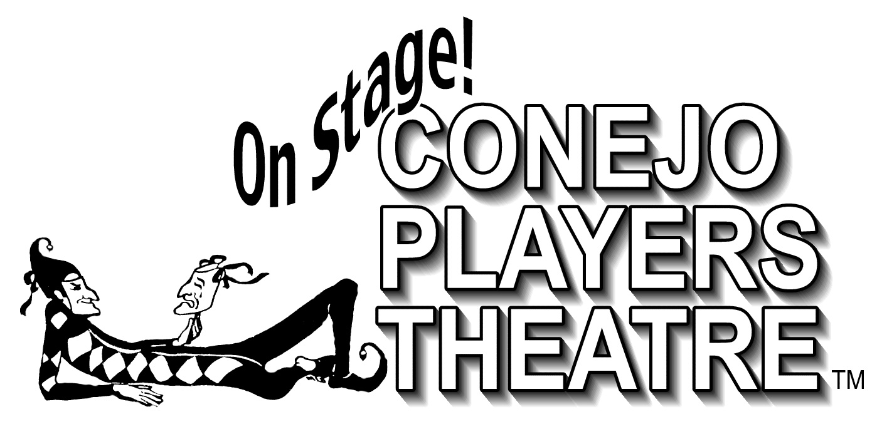

Dear ___________________________________________,

The Conejo Players Theatre is an all-volunteer, non-profit organization that relies on individuals such as you to help produce our season each year. On behalf of the Board of Directors, thank you for your service to our community through the hours and activities noted below.

________________________________________________________________
Production/Activity:

______________________________ __________________________
Number of hours Dates

______________________________ __________________________
Signature Date

______________________________
Title

